|  |  |
| --- | --- |
| Keyword | Definition |
|  |  |
|  |  |
|  |  |
|  |  |
|  |  |
|  |  |
|  |  |
|  |  |
|  |  |
|  |  |

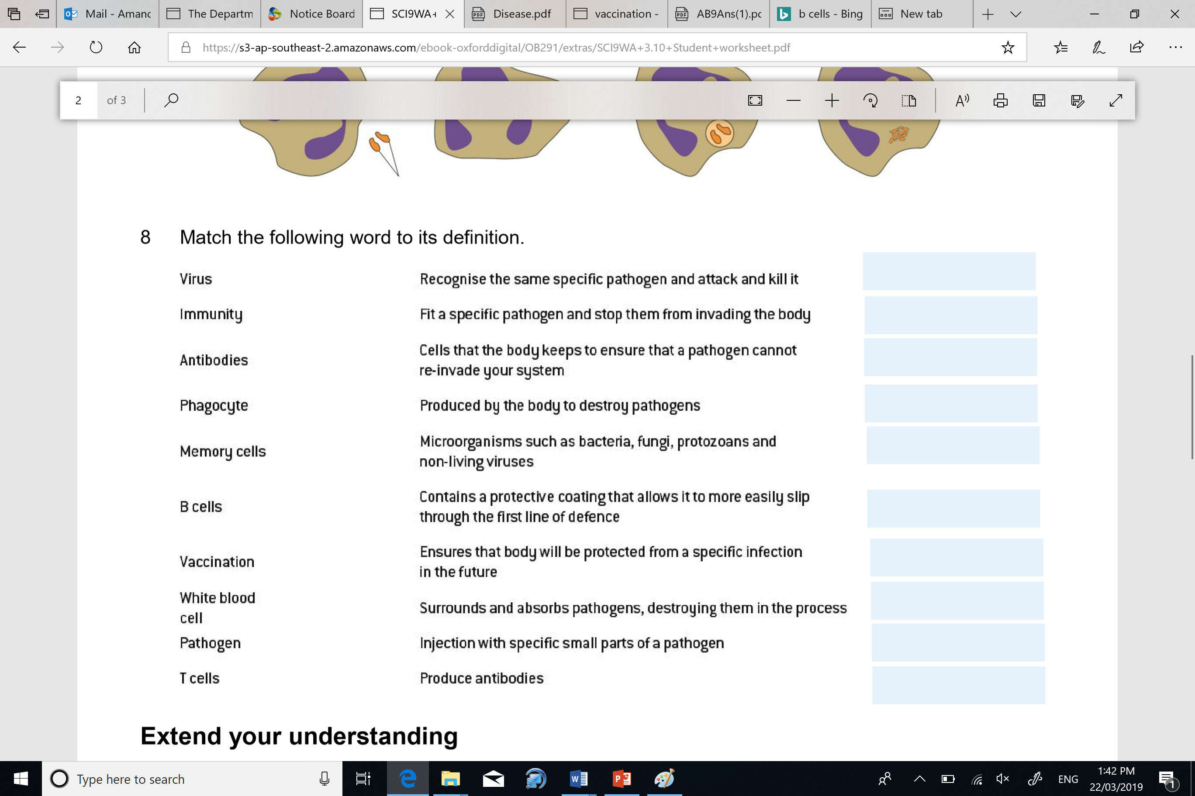

|  |  |
| --- | --- |
| Keyword | Definition |
|  |  |
|  |  |
|  |  |
|  |  |
|  |  |
|  |  |
|  |  |
|  |  |
|  |  |
|  |  |